Mary, Mother of the Son

Join us for a special Adult Faith presentation Monday, December 5th at 7pm at St. Brendan Catholic Church.

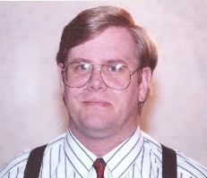
Mark Shea, a well-known Catholic blogger and published author of Catholic books will be speaking to us about Mary, an especially timely topic both for Advent, and as we celebrate the Feast of the Immaculate Conception.

Admission is free, but please RSVP on our Facebook page at: https://www.facebook.com/events/371182143226806/

Mr. Shea will have available for purchase a selection of his books, including his recent book: “Mary, Mother of the Son” Here is what other Catholic authors say about Mark Shea’s new book:

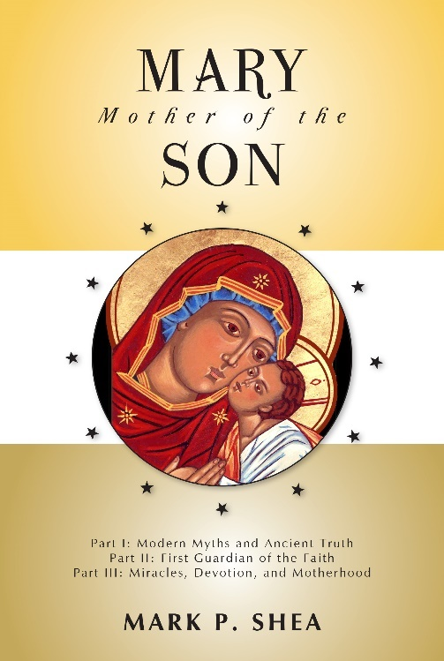
“Mark Shea has written the single most helpful book on Sacred Tradition written in our generation. In other books he has illumined the reading of Scripture and the worship of the Eucharist. Now, in Mary, Mother of the Son, he takes us to the summit of creation, the Ark of the New Covenant, the true tabernacle of the Lord. To read this book is to love Christ as a brother, by honoring the mother he shares with us (John 19:27).”
—Scott Hahn, Ph.D., Professor of Scripture and Theology, Franciscan University of Steubenville; Author, Hail, Holy Queen

“Mark Shea’s Mary, Mother of the Son is a comprehensive and engaging treatment of the Church’s teaching on Mary. A skilled writer, he renders complexities with simplicity without diluting them in the least. His own past experience as an Evangelical Christian and now Catholic enable him to offer helpful and thorough answers to the most common—and uncommon—questions readers from any background might have about Mary.”
—Amy Welborn, Author, Mary and the Christian Life

For more information about Mark, and his writings, please visit his web page at: http://mark-shea.com/index.html

